1.) less f4

This command is used to display the data page by page

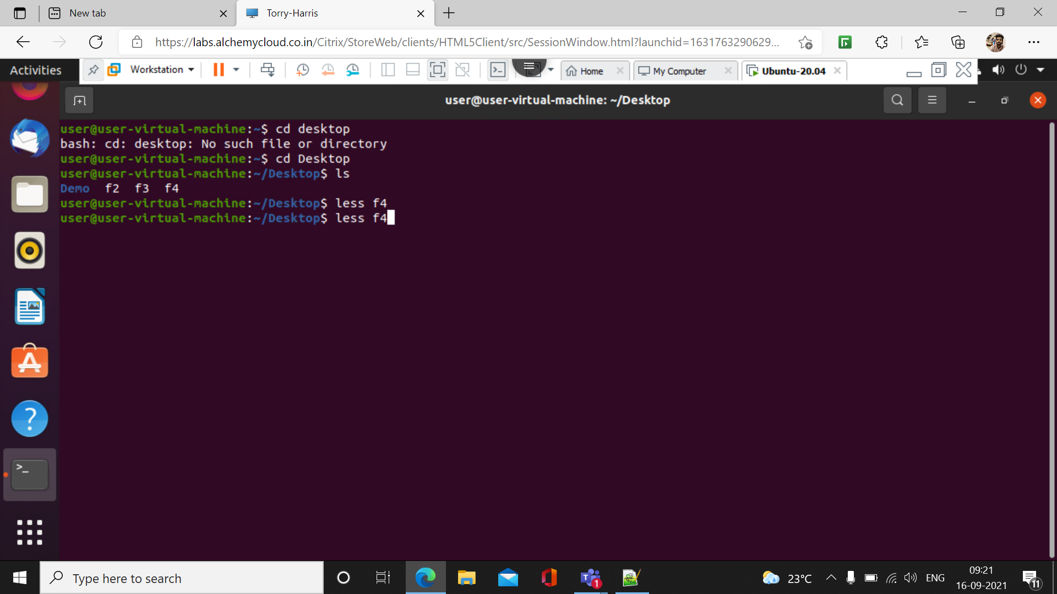

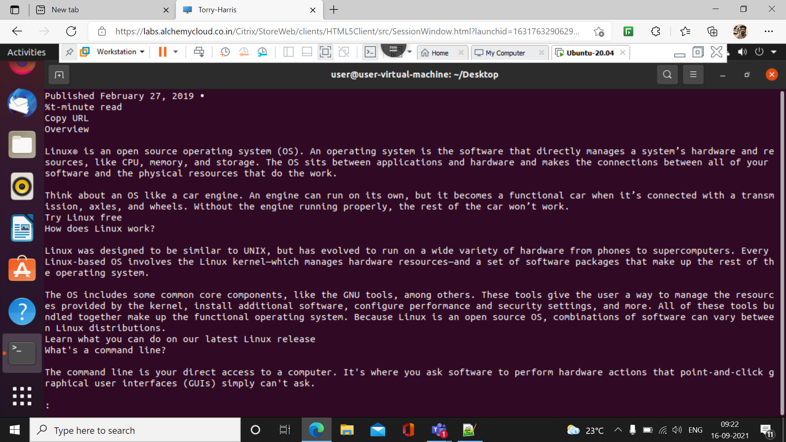

2.) less -p ‘open’ f4

This command is used to search the specific keyword in the data

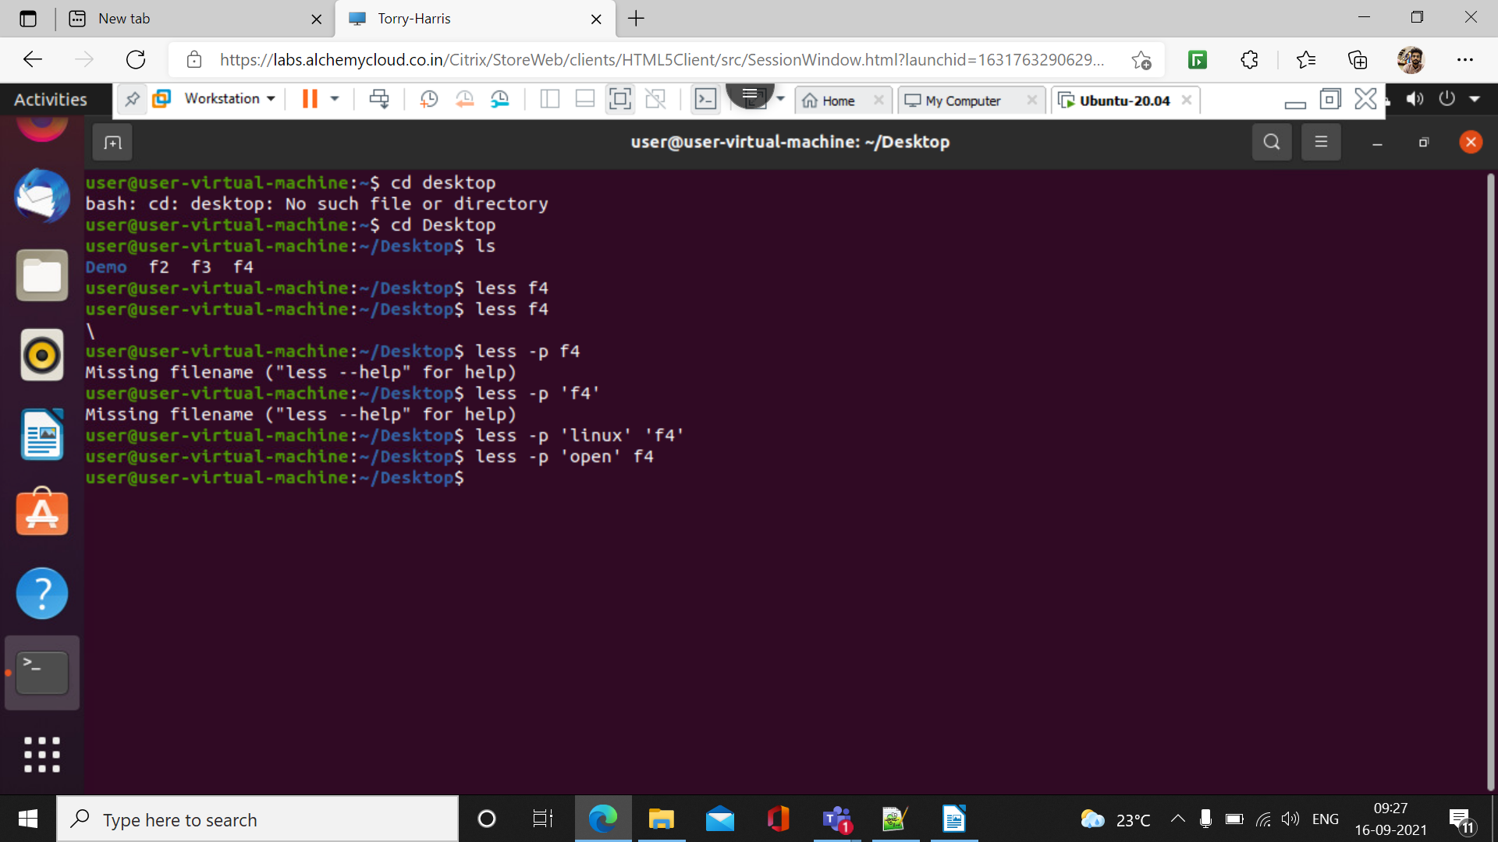

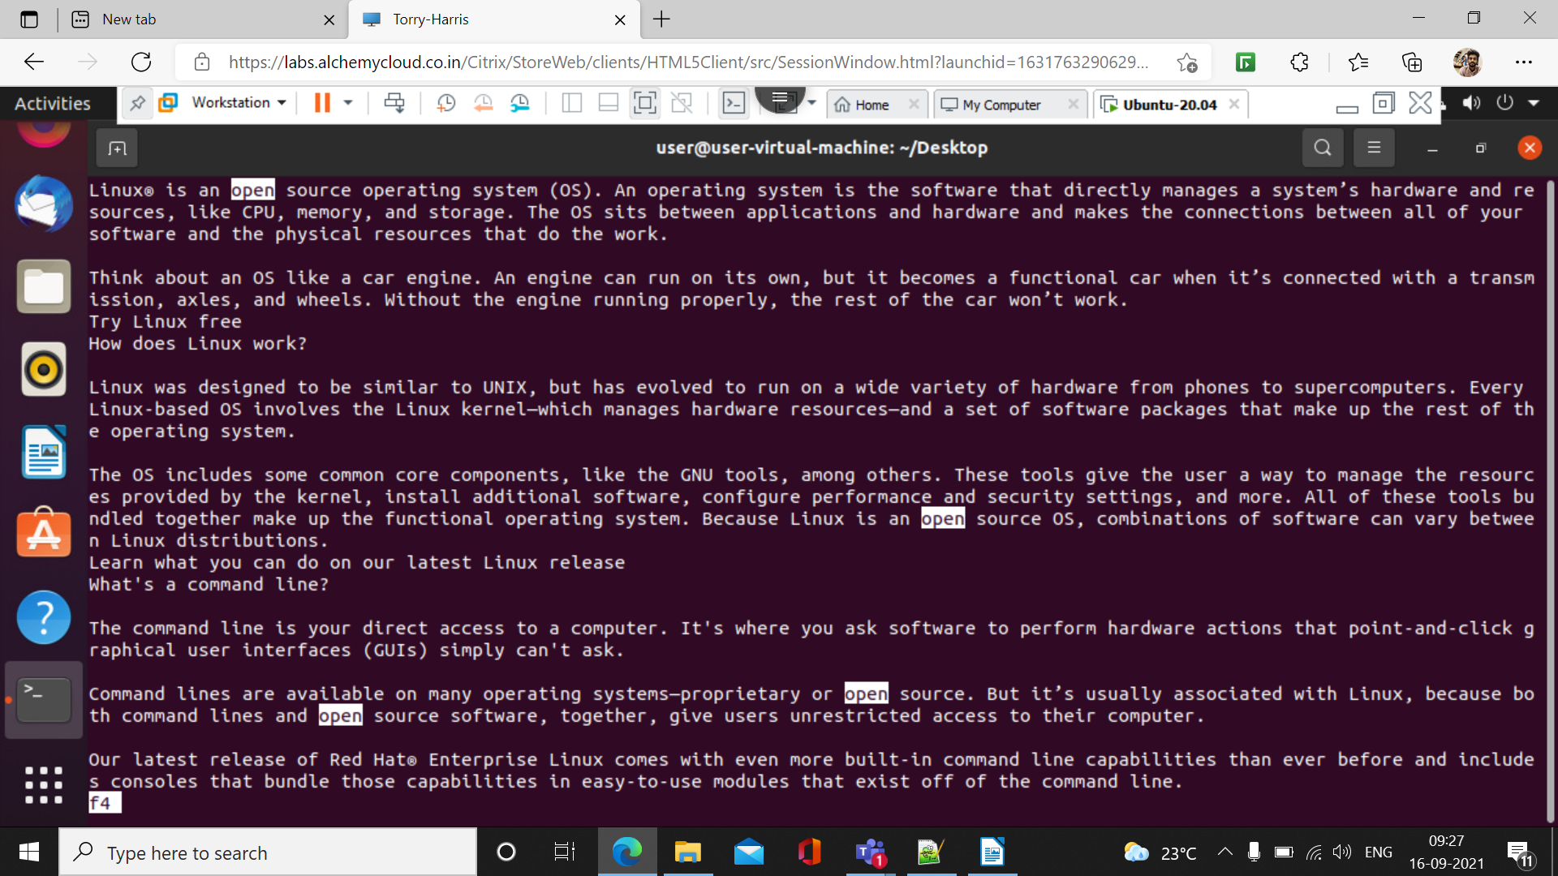

3.) less – N f4

This command is used to display the line numbers for ever lines present in the data

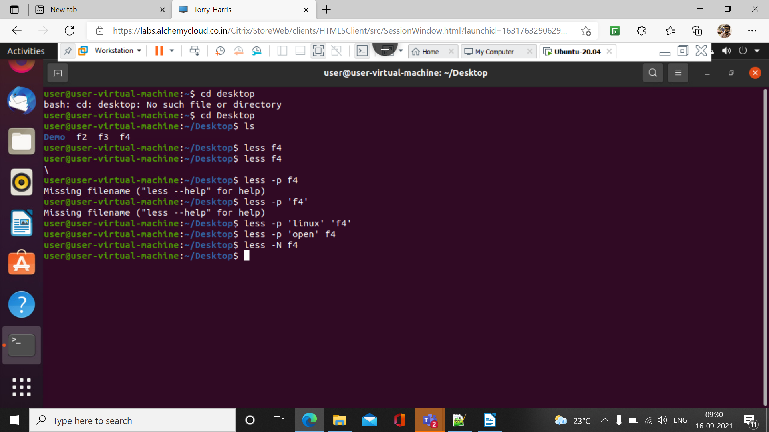

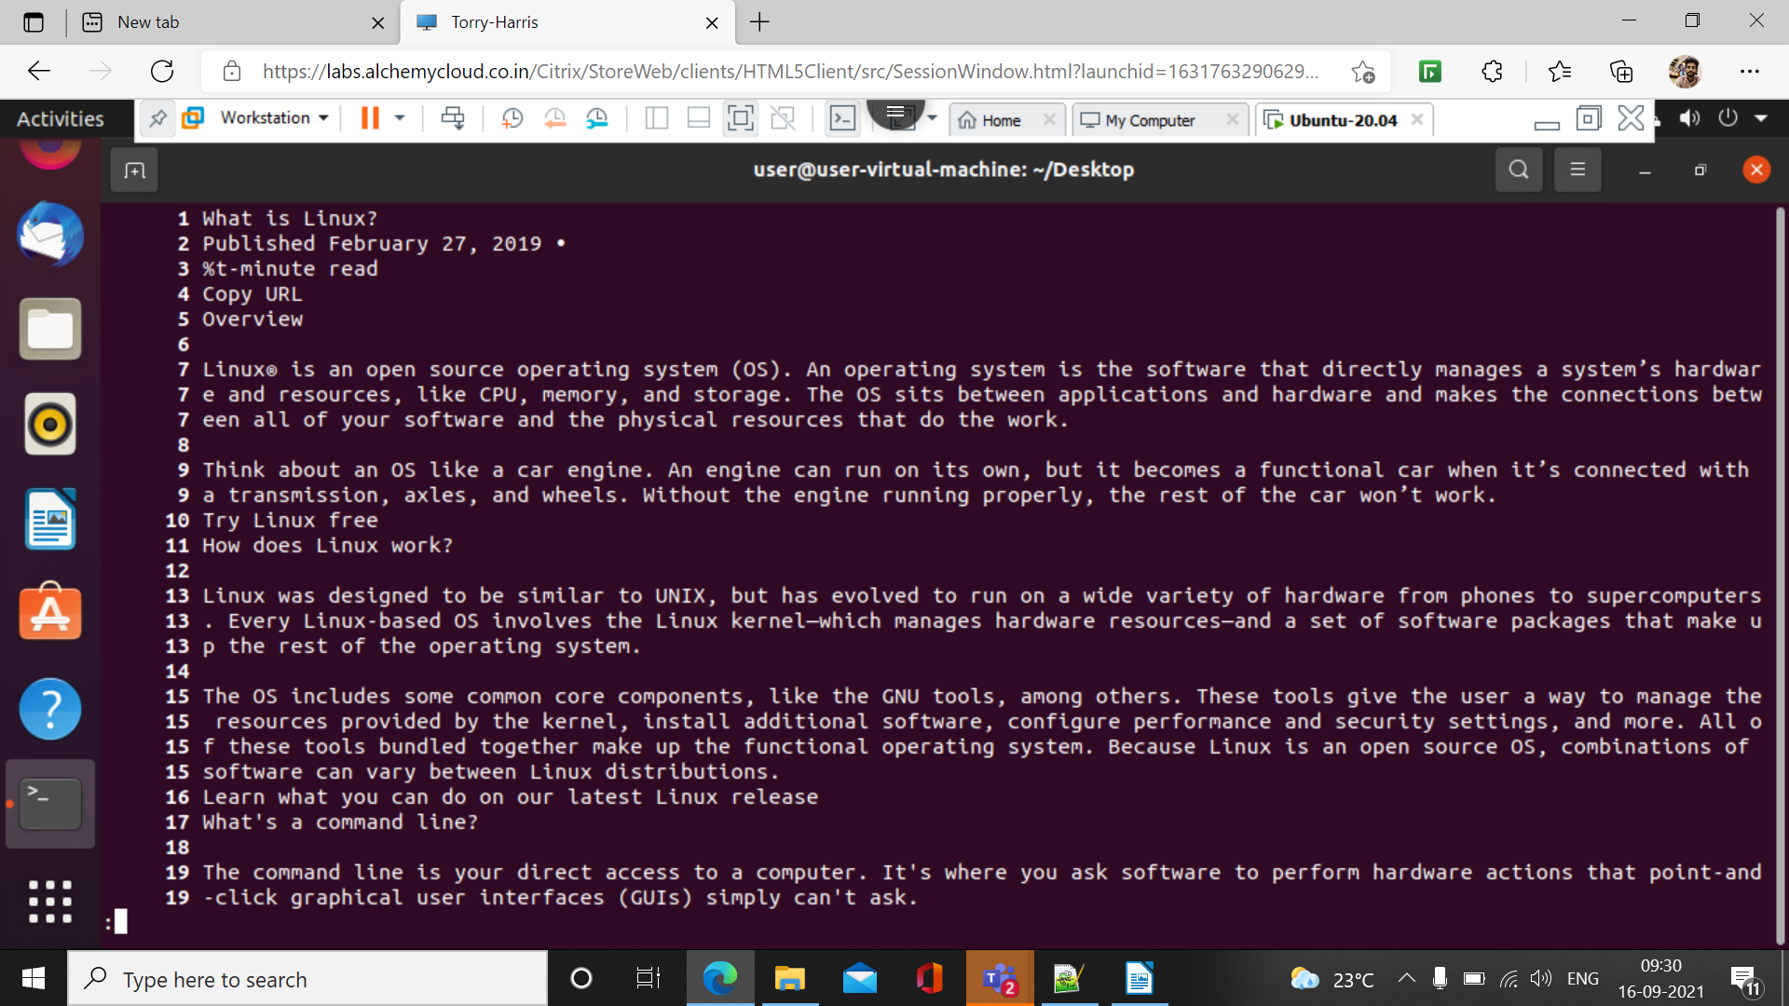

4.) To create a file in Vim(:w file name)

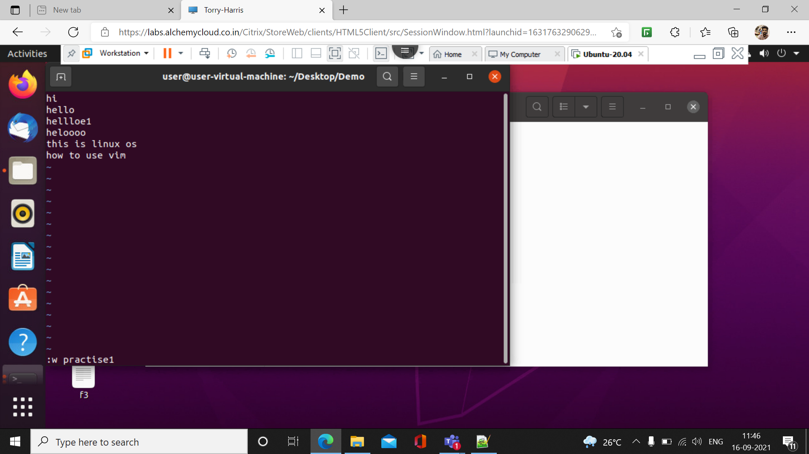

5: To exit the vim terminal (:q)

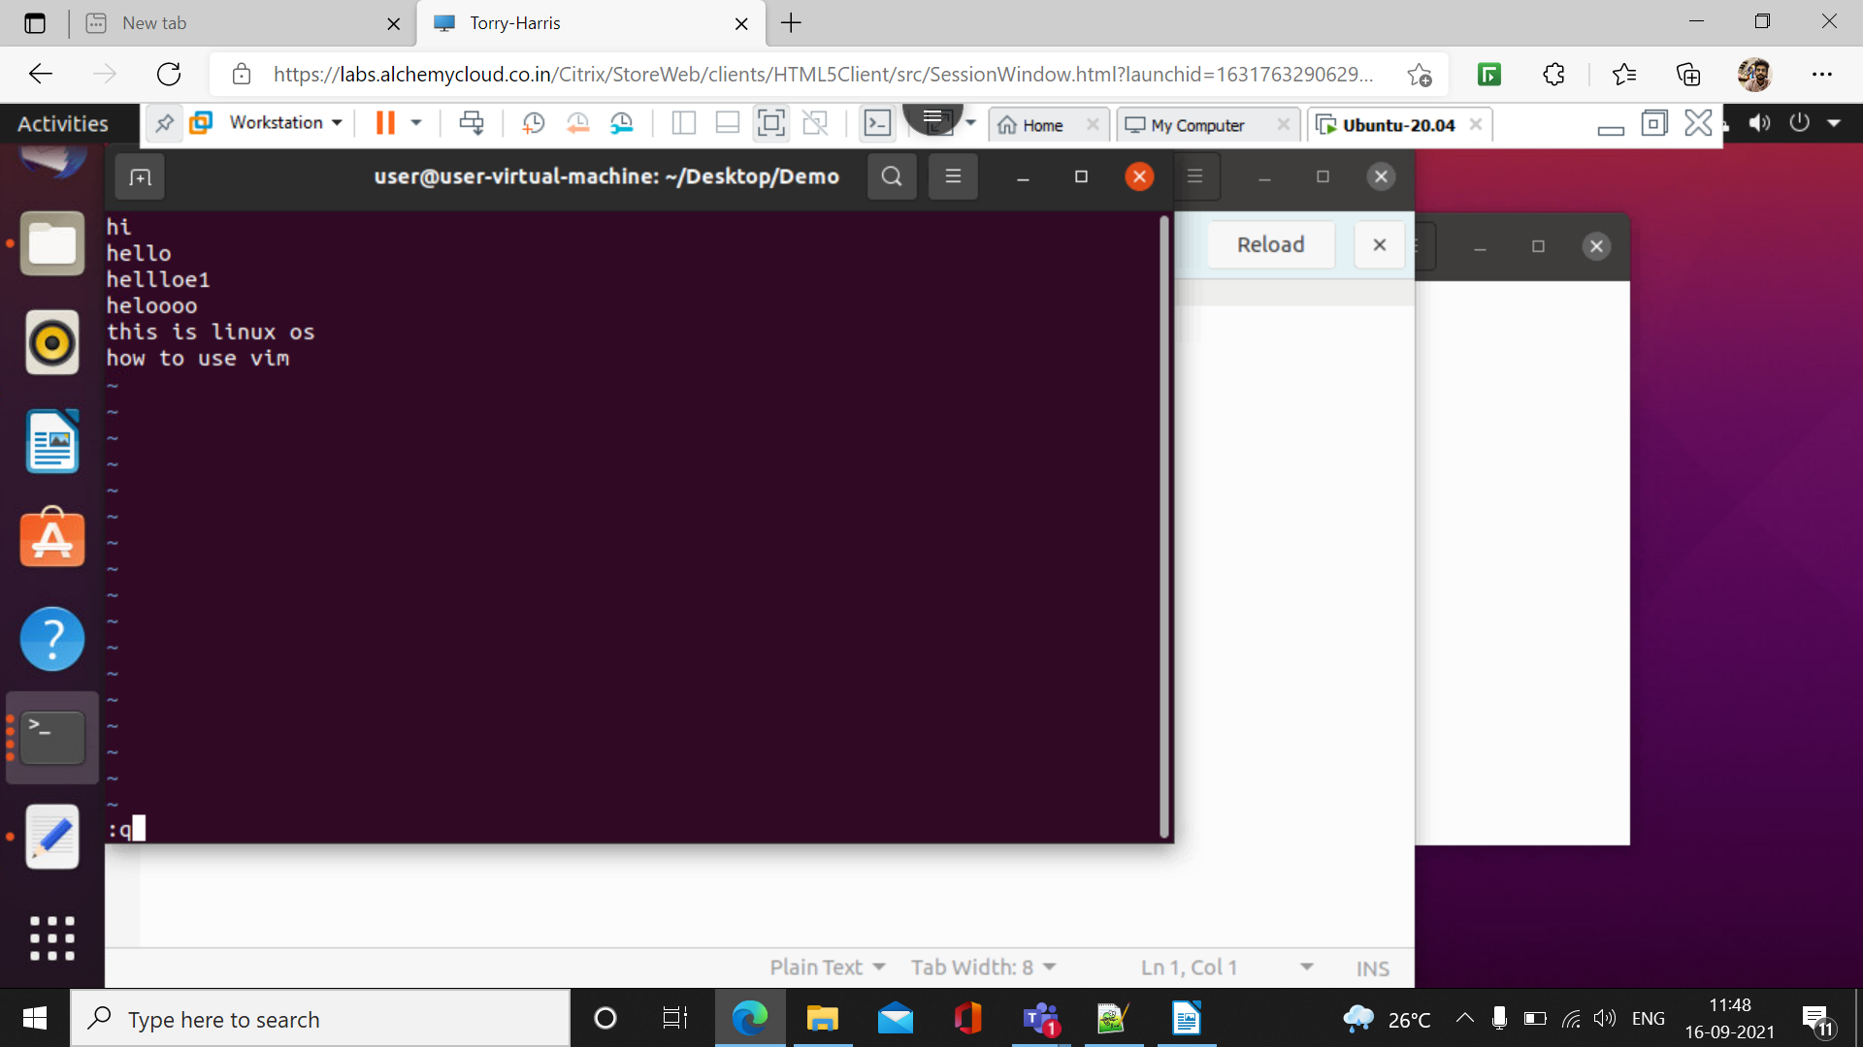

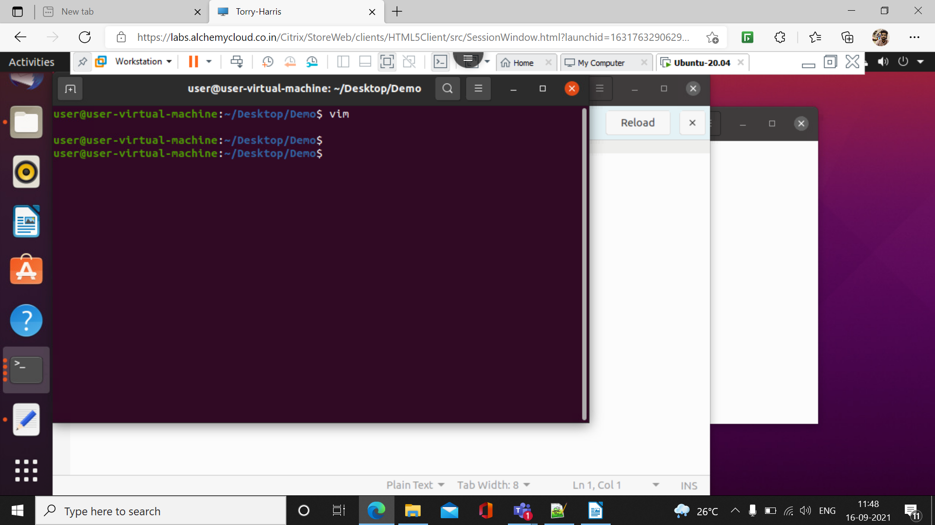

6.) To copy the data from one file to another( :w filename)

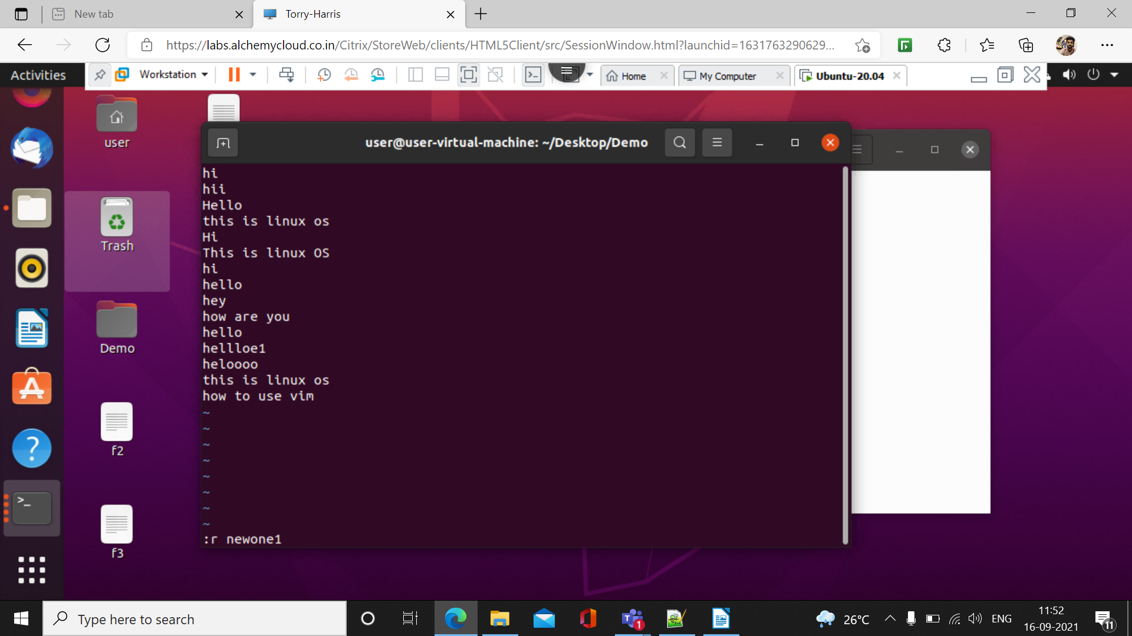

7.) To quit without saving the file

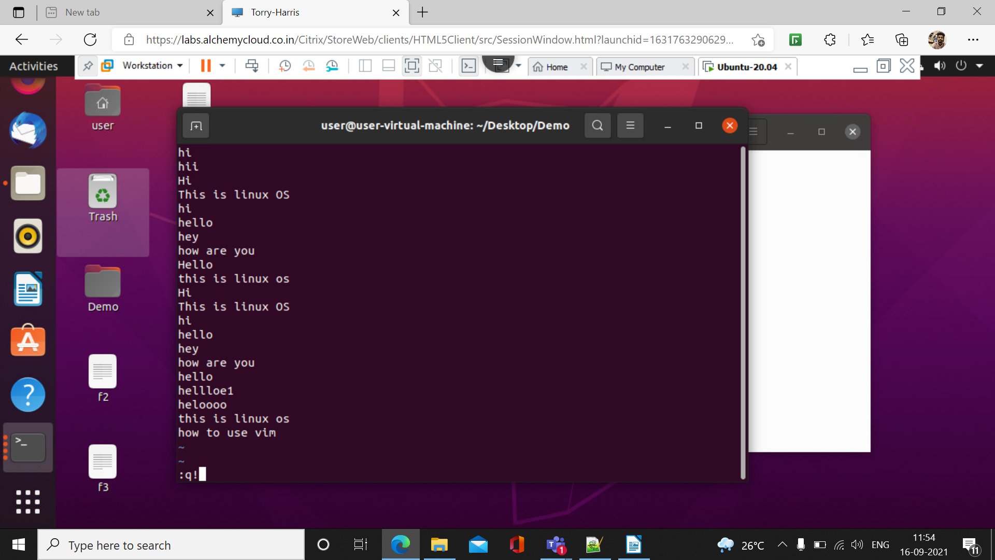8.) head

This command is used to display the first 10 items present in the data

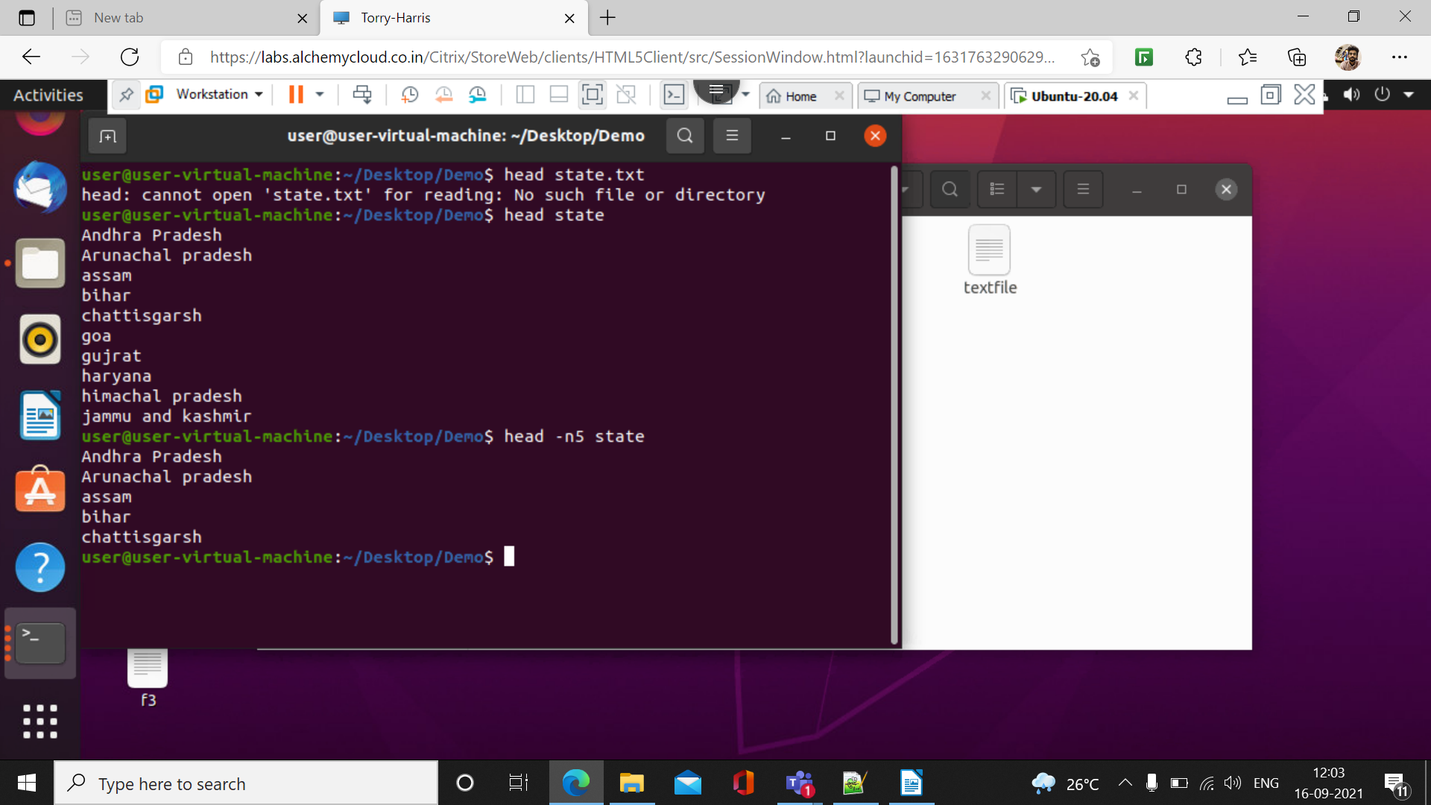

9.) tail

Tail command prints the last n numbers of data of the given input

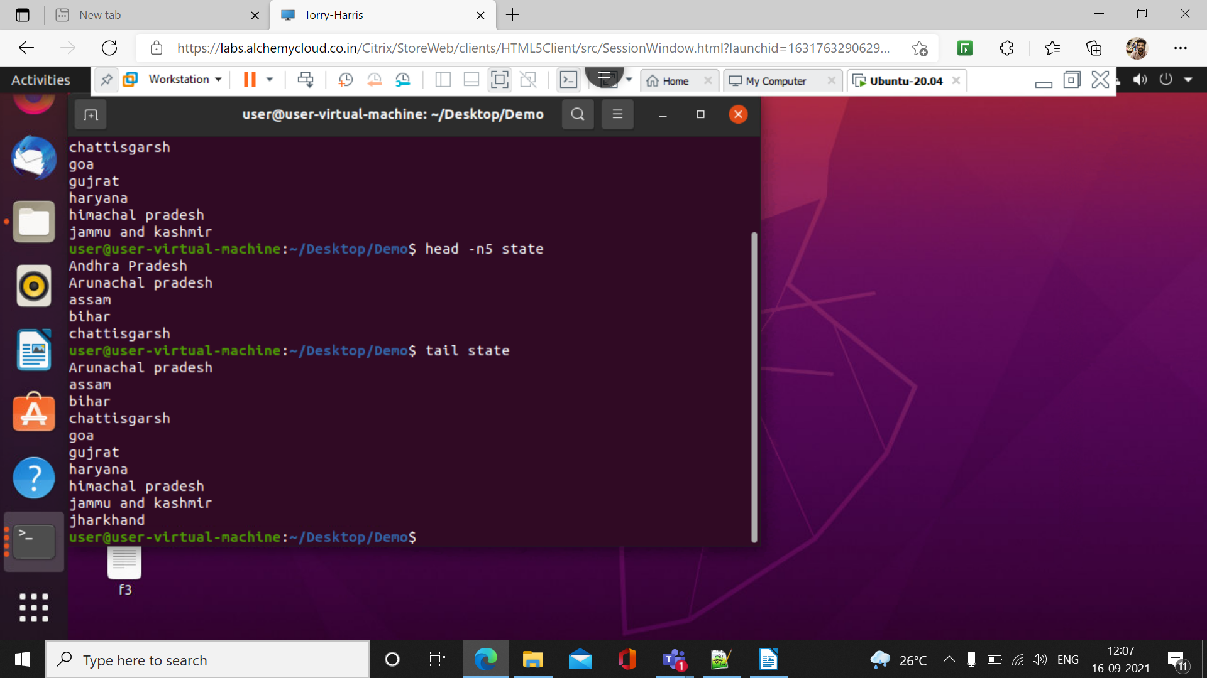

10.)